Feasibility Analysis:

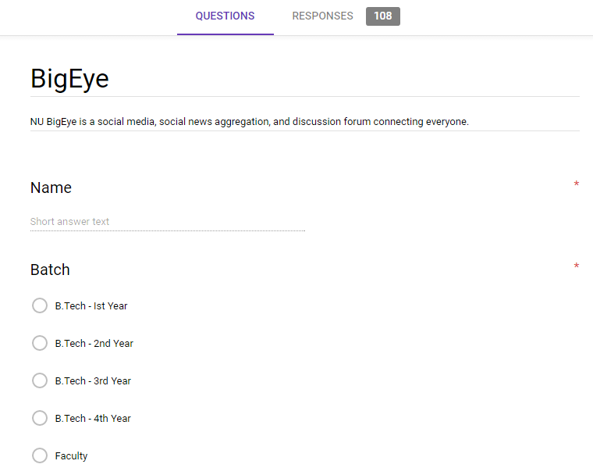**Description of the software:**

This is the feasibility analysis of our website ,which give the total information about the campus activities and gives the guidance from seniors on the issues of projects they have done. They can get guidance from the professors through this website. User can get previous question papers and aptitude tests.

